

E-Commerce & Digital Marketing
( Course Code: CSC417 )

Name: Muhammad Abdullah
Roll No # FA24-BSE-042
Instructor Name: Mam Faiqa

Lab Assignment# 3
Lab Activity 1:
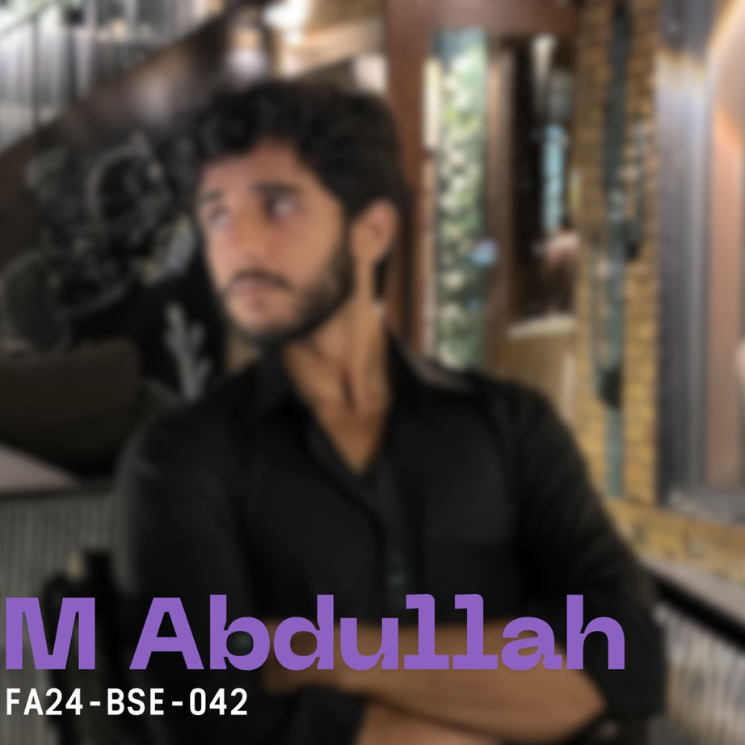
Lab Activity 2:

Lab Activity 3:
Booklee is my startup, which is a AI-Receptionist for Service Based Businesses. It streamlines customer services, follow-up and make bookings easy.
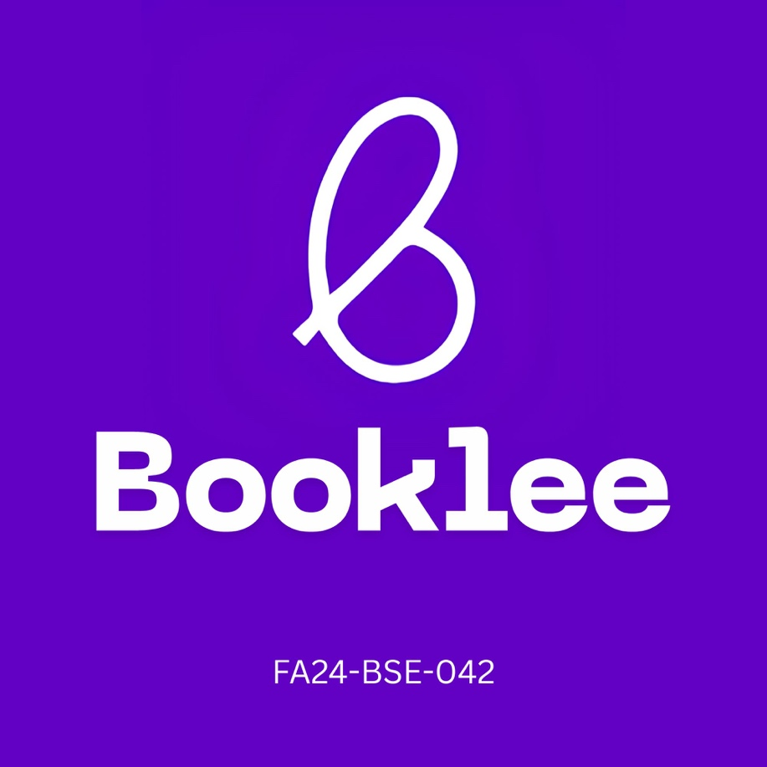

Lab Activity 4:
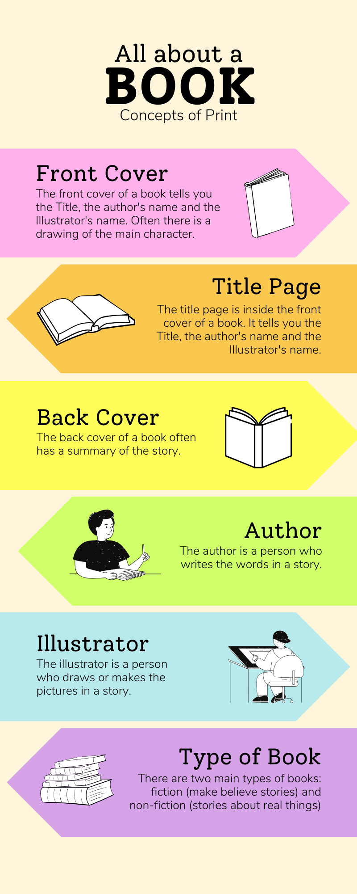

Task-1:
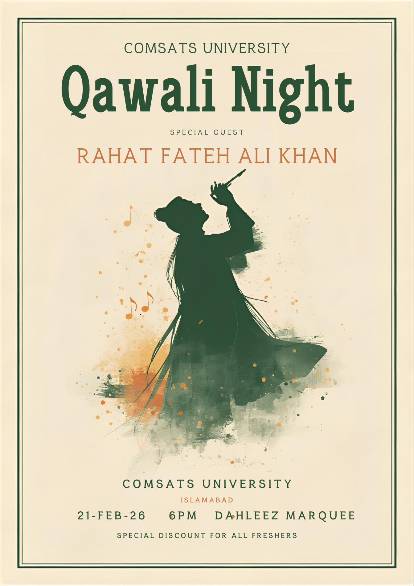
Task-2:


